DEPARTMENT OF COMPUTER SCIENCE

**A Purkinje Cell Model that Simulates Complex Spikes**

**Stefanos Charakidis**

A dissertation submitted to the University of Bristol in accordance with the requirements of the degree of Bachelor of Science in the Faculty of Engineering.

Thursday, 17 March, 2022

Word Count : 3740

**Abstract**

Purkinje cells are the principal neurons of the cerebellar cortex. One of their distinguishing features is that they fire two distinct types of action potential, called simple and complex spikes, which interact with one another. Simple spikes are stereotypical action potentials that are elicited at high, but variable, rates (0 − 100 Hz) and have a consistent waveform. Complex spikes are composed of an initial action potential followed by a burst of lower amplitude spikelets. Complex spikes occur at comparatively low rates (∼ 1 Hz) and have a variable waveform. Although, they are critical to all motor coordination in the cerebellar cortex, a simple model that describes the complex spike waveform is lacking. ++

**Dedication and Acknowledgements**

Throughout this dissertation thesis, I have received a lot of support and assistance both mentally and physically. I would like to personally thank my supervisor, Professor Conor Houghton, whose expertise was critical in and methodology. By having a great collaboration, you helped me set ambitious goals and pay attention to details, always guiding me to the points I should dedicate my time and effort to. Along with Conor I would like to thank Amelia Burroughs, Nadia L. Cerminara and Richard Apps from School of Physiology, Pharmacology and Neuroscience, University of Bristol for their contributions in the original research paper [1]. I may not have met you, but I would like to express my gratitude for conducting research on this topic and as a result allowing me to take another look from the computer science viewpoint.

**Declaration**

I declare that the work in this dissertation was carried out in accordance with the requirements of the University’s Regulations and Code of Practice for Taught Programmes and that it has not been submitted for any other academic award. Except where indicated by specific reference in the text, this work is my own work. Work done in collaboration with, or with the assistance of others, is indicated as such. I have identified all material in this dissertation which is not my own work through appropriate referencing and acknowledgement. Where I have quoted or otherwise incorporated material, which is the work of others, I have included the source in the references. Any views expressed in the dissertation, other than referenced material, are those of the author.

Stefanos Charakidis, Thursday, 17 March, 2022

***Contents***

Introduction 1

Background 4

Project Execution 5

3.1 Ion Channels 6

3.2 Hodgkin-Huxley model 8

Critical Evaluation 15

4.1 Results 15

4.2 Discussion 15

Conclusion 16

Bibliography 17

**List of Figures**

3.1 This is an example figure. . . . . . . . . . . . . . . . . . . . . . . . . . . . . . . . . . . . . 13

**List of Tables**

3.1 This is an example table. . . . . . . . . . . . . . . . . . . . . . . . . . . . . . . . . . . . . 13

**Ethics Statement**

“This project did not require ethical review, as determined by my supervisor, Conor Houghton.”

**Supporting Technologies**

The following hardware and software tools were used for the production of this dissertation:

* Thesis written using Microsoft Word tools.
* Simulations were run in Python v3.9.10, Windows 11(64 bit) OS on an Intel Core i7-9750H CPU.
* I used **NumPy** and **Matplotlib** Python libraries to process and visualize the model data from [NumPy](https://numpy.org/) and [Matplotlib — Visualization with Python](https://matplotlib.org/).
* I used the **time** Python module to monitor the execution time from [time — Time access and conversions — Python 3.10.2 documentation](https://docs.python.org/3/library/time.html).
* Models were simulated as ordinary differential equations and integration was performed explicitly using the **scipy.integrate.solve_ivp** package suitable for stiff problems from [scipy.integrate.solve_ivp — SciPy v1.8.0 Manual](https://docs.scipy.org/doc/scipy/reference/generated/scipy.integrate.solve_ivp.html).

**Notation and Acronyms**

The following table provides clarifications and guidance on any Acronyms used in this paper.

|  |  |
| --- | --- |
| Acronym | Description |
| PC | Purkinje Cell |
| CS | Complex Spike |
| SS | Simple Spike |
| GABA | Gamma-Aminobutyric Acid |
| HH | Hodgkin-Huxley |

**Chapter 1**

# Introduction

Located in the cerebellum and being amongst the largest neurons in the central nervous system [2], Purkinje cells(PCs) are extraordinary and instantly distinguishable from other brain neurons for their complex planar dendritic trees and for their ability to fire to distinct types of action potential, namely simple and complex spikes. With over 150,000 input synapses, far most than most other cell types [3] PCs have gathered the interest of many neuroscientists of their potential and capabilities.

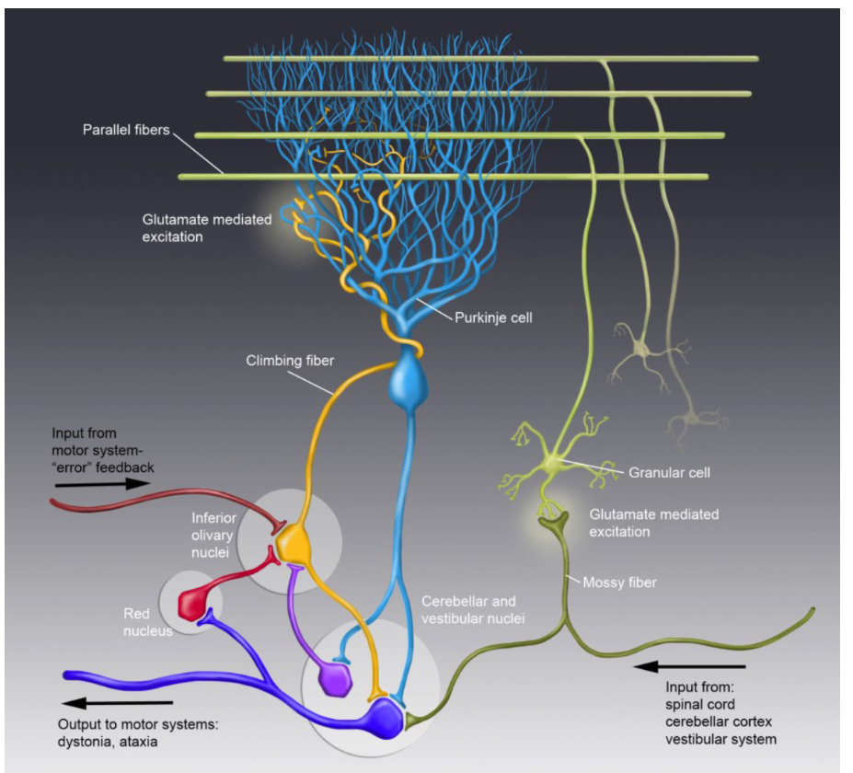

Figure 1.1: Purkinje cell layout. Climbing fibres receive input from motor system where they are thought to code error signals [13] and connecting directly to the parallel fibres. In contrast mossy fibre connects to parallel fibres via the Granular cell having received input from multiple sources(spinal cord, cerebellar cortex, vestibular system ).

The mossy fibre activates the granule cell which connects to the parallel fibre exciting Simple Spikes(SSs) (see Figure 1.1), ranging from 0 – 100 Hz . On the other hand, the climbing fibre “entangles” the PC where it directly triggers Complex Spikes (CSs) at a remarkably low frequency (~1 Hz) [4] with one climbing fibre per PC (see Figure 1.1). CSs can induce long-term depression at parallel fibre synapses on PCs, which may be involved in cerebellum-dependent learning and motor coordination [5] [6]. Purkinje cells are GABAergic neuron and are the only neurons that send output from the cerebellar cortex to nuclear neurons [7].

Despite the existence of a range of computational models to address various features of Purkinje cells, a simple model that captures the complex spike behaviour is lacking . An extensive attempt to create the necessary model to address the issue has been done by Amelia Burroughs, Nadia L. Cerminara , Richard Apps , and Conor Houghton [1]. Here, this paper seeks to review and rework the modelling from the computer science perspective in order to provide an efficient, optimized, and simplistic solution without losing the resolution of the original paper. This paper’s aim is via simulation, to prove the hypothesis that a restricted number of channel-dynamics can explain the complex spike waveform. The model that is presented is a three-current representation that shows that three channels, a leak channel and two active channels, are sufficient to simulate the complex spike waveform. This model attempts to provide an adequate description of the essential ion-channel dynamics that support the complex spike production, behaviour and enable further analysis of complex spiking.

In short, this project will cover the following points:

1. Introduce a model that simulates the CS behaviour.
2. Review and re-implement the Hodgkin and Huxley model, in a more contemporary version.
3. Provide extensive figures and graphs that would explain the CS waveform.
4. Produce an optimized and efficient code in terms of time and computational power.
5. Assess the accuracy and the strength of the model and provide solutions to mitigate numerical errors that occur.

---------------------------------------------------------------------------------------------------------------------------

This chapter should introduce the project context and motivate each of the proposed aims and objectives. Ideally, it is written at a fairly high-level, and easily understood by a reader who is technically competent but not an expert in the topic itself.

In short, the goal is to answer three questions for the reader. First, what is the project topic, or problem being investigated? Second, why is the topic important, or rather why should the reader care about it? For example, why there is a need for this project (e.g., lack of similar software or deficiency in existing software), who will benefit from the project and in what way (e.g., end-users, or software developers) what work does the project build on and why is the selected approach either important and/or interesting (e.g., fills a gap in literature, applies results from another field to a new problem). Finally, what are the central challenges involved and why are they significant?

The chapter should conclude with a concise bullet point list that summarises the aims and objectives.

**Chapter 2**

# Background

This chapter is intended to describe the background on which execution of the project depends. This may be a technical or a contextual background, or both. The goal is to provide a detailed explanation of the specific problem at hand, and existing work that is relevant (e.g., an existing algorithm that you use, alternative solutions proposed, supporting technologies).

Per the same advice in the handbook, note there is a subtly difference from this and a full-blown literature review (or survey). The latter might try to capture and organise (e.g., categorise somehow) *all* related work, potentially offering meta-analysis, whereas here the goal is simple to ensure the dissertation is self-contained. Put another way, after reading this chapter a non-expert reader should have obtained enough background to understand what *you* have done (by reading subsequent sections), then accurately assess your work against existing relevant related work. You might view an additional goal as giving the reader confidence that you are able to absorb, understand and clearly communicate highly technical material and to situate your work within existing literature.

----------------------------------------------------------------------------------------------------------------------------

A published research paper(not certified by peer review) was made by Amelia Burroughs, Nadia L. Cerminara , Richard Apps , and Conor Houghton [1], in an effort to fully explain the CS behaviour. The paper was extensive covering two models: a three current and a five current model. The later one was used to demonstrate that calcium dynamics could explain the interactions between simple and complex spikes. This dissertation project focused exclusively on the three current model which could be able to efficiently simulate the complex spike waveform. The task was to re-implement the three current model with a newer and better code in terms of efficiency and readability as the code that was used for the original paper did not possess the flexibility needed in these situations.

ADD PHD STUDENTS WORK HERE AND HODGKIN-HUXLEY MENTION

**Chapter 3**

# Project Execution

This chapter is intended to describe what you did: the goal is to explain the main activity or activities, of any type, which constituted your work during the project. The content is highly topic-specific, but for many projects it will make sense to split the chapter into two sections: one will discuss the design of something (e.g., some hardware or software, or an algorithm, or experiment), including any rationale or decisions made, and the other will discuss how this design was realised via some form of implementation.

This is, of course, far from ideal for *many* project topics. Some situations which clearly require a different approach include:

In a project where asymptotic analysis of some algorithm is the goal, there is no real “design and implementation” in a traditional sense even though the activity of analysis is clearly within the remit of this chapter.

In a project where analysis of some results is as major, or a more major goal than the implementation that produced them, it might be sensible to merge this chapter with the next one: the main activity is such that discussion of the results cannot be viewed separately.

Note that it is common to include evidence of “best practice” project management (e.g., use of version control, choice of programming language and so on). Rather than simply a rote list, make sure any such content is useful and/or informative in some way: for example, if there was a decision to be made then explain the trade-offs and implications involved.

----------------------------------------------------------------------------------------------------------------------------

In this paper a model of the Purkinje cell somatic voltage dynamics is presented with a three-current model, which has a leak channel and two voltage-gated channels:

( 1 )

where Cm = 1 μF / cm2 is the membrane capacitance, is a leak current,

( 2 )

with = 0.3 mS / cm2 and = 10.613 mV. INa and IK stand for the sodium current and the potassium current.stands for the external input current. This is described below and is made up of a background current and a synaptic current entering the soma from the dendrites The most commonly used sign convention in neural modeling is that ionic current flowing out of the cell is positive and ionic current flowing into the cell is negative [8].

## 3.1 Ion Channels

The current through the sodium channel was modelled using a Markovian scheme developed by Raman and Bean [9] , as seen in Table 1. This scheme models the dynamics of both the transient and resurgent gate. The sodium current is:

( 3 )

Where *o* is the fraction of gates in the open state O, = 120.0 mScm−2 and VNa = 115 mV

Table 1: Sodium channel current described using a Markovian Scheme. “C1-C5 describe sequential closed configurations; I1-I6 describe sequential inactivated states; O represents the open channel configuration where sodium ions only pass through the channel when it is in this state. B describes a second inactivated state where the channel is likened to being in an open-but-blocked configuration that is non-conducting. Return from this state back to the closed, or inactivated, states must occur through the open (O) configuration” [1].

Where

( 4 )

( 5 )

( 6 )

and γ = 150 ms−1 , δ = 40 ms−1 , ε = 1.75 ms−1 , D = 0.005 ms−1 , U = 0.5 ms−1 , N = 0.75 ms−1 , F = 0.005 ms−1 with

( 7 )

The potassium current is:

( 8 )

Where , = 36.0 mScm−2 and VK = -12 mV. *n* is described with the usual Hodgkin-Huxley channel equations(Eq 17, Eq 18) described in 2.2.

foo

Figure 3.1: This is an example figure.

|  |  |  |
| --- | --- | --- |
| foo | bar | baz |
| 0 | 0 | 0 |
| 1 | 1 | 1 |
| ... | ... | ... |
| 9 | 9 | 9 |

Table 3.1: This is an example table.

## 3.2 Hodgkin-Huxley model

### 3.2.1 Sign Convention

One issue while implementing the Hodgkin-Huxley model was the voltage sign convention. The modern convention is that depolarization makes the membrane potential Vm more positive [10]. However, Hodgkin and Huxley [11] used the opposite sign convention (depolarization negative) in their paper. Figures and parameters in this paper follow the modern convention that depolarization is positive. The modern convention is chosen in order to display a more modern example of the Hodgkin-Huxley model. To achieve this, the HH equations and the voltage values have been adjusted accordingly.

### 3.2.2 Hodgkin-Huxley model implementation

The **Hodgkin–Huxley model**, or **conductance-based model**, is a mathematical model that describes how action potentials in neurons are initiated and propagated. It is a set of nonlinear differential equations that approximates the electrical characteristics of excitable cells such as neurons. It is a continuous-time dynamical system.

The typical Hodgkin–Huxley model treats each component of an excitable cell in this case a Purkinje cell as an electrical element. The lipid bilayer is represented as a capacitance (Cm). Voltage-gated ion channels are represented by electrical conductances (, for the potassium channel and for the sodium channel) that depend explicitly on voltage. Leak channels are represented by linear conductances (). Finally, the membrane potential is denoted by *Vm,* and it is time dependent.

Thus, for a cell with sodium and potassium channels, the total current through the membrane is given by:

( 9 )

The Hodgkin and Huxley developed a model in which the properties of an excitable cell are described by a set of four ordinary differential equations. Together with the equation for the total current mentioned above, these are:

( 10 )

( 11 )

( 12 )

( 13 )

where *I* is the current per unit area, and α{\displaystyle \alpha _{i}} and {\displaystyle \beta _{i}}β are rate constants for the each ion channel, which depend on voltage but not time. There are three gating variables: n for the Potassium channel activation, m for the Sodium channel activation (opening) and h for the Sodium channel inactivation (closing). The value of a gating variables is dimensionless and will vary between 0 and 1; 0 indicates that the channel is closed, whereas 1 indicates that the channel is open. The gating variable fraction is an indication of the conductance of a certain ion at a given time and membrane voltage

( 14 )

( 15 )

( 16 )

(n,m,h)∞ are the steady state values for activation and are usually represented as a function of Vm.

A system of four ordinary differential equations is used to represent the Hodgkin-Huxley model as seen in Eq 10, Eq 11, Eq 12, Eq 13. As a nonlinear system it is difficult for the model to be studied as it cannot be solved analytically However, certain properties and general behaviors, such as limit cycles(closed trajectories), can be proven to exist using numerical methods. A picture containing chart

Figure 3: Limit cycles of the gating variables as a function of Voltage

Channel kinetics are described with the original Hodgkin-Huxley channel equations [11] and constants with, α, β being the forward and backwards rate in ms-1, respectively.

( 17 )

( 18 )

( 19 )

( 20 )

( 21 )

( 22 )

One other technical note is that certain function forms can become indeterminate at certain voltage values(Nelson05-ElectrophysModels). Given a specific voltage, an(Vm) and am (Vm) may evaluate to the indeterminate form 0/0. The solution to this problem is to apply L’Hospital’s rule [12], which states that if f(x) and g(x) approach zero as x approaches a, and f ‘(x)/ g’(x) approaches L as x approaches a, then the ratio f (x)/ g(x) approaches L as well. Using this rule, it can be shown that an(10) = 0.1 and am(25) = 0.430825375 . Also, the limits for every case are hand-tuned for simplicity and efficiency.

All the input parameters listed in Table 2, are defined in Python.

|  |  |  |
| --- | --- | --- |
| ***Parameters*** | ***Chosen Value*** | ***Reference*** |
| Cm (μF/cm2) | 1.0 | [11] |
| (mS/cm­­2) | 120.0 | [11] |
| (mS/cm­­2) | 36.0 | [11] |
| (mS/cm­­2) | 0.3 | [11] |
| Vm (mV) | 0.0 | [11] |
| VNa (mV) | 115.0 | * [11] |
| VK (mV) | -12.0 | * [11] |
| Vl (mV) | 10.613 | * [11] |
| VThreshold (mV) | 55.0 | * [11] |
| Iinj (μA/cm2) | 10.0 |  |
| Tmax (ms) | 35.0 |  |

Table 2: Experimental Constants for the Hodgkin and Huxley model. The parameters with a star (*) have been hand-tuned to have their signs follow the sign convention see Section 3.1.

Figure 4: Neuron potential as a function of time

**Chapter 4**

# Critical Evaluation

This chapter is intended to evaluate what you did. The content is highly topic-specific, but for many projects will have flavours of the following:

1. functional testing, including analysis and explanation of failure cases,
2. behavioural testing, often including analysis of any results that draw some form of conclusion wrt. the aims and objectives, and
3. evaluation of options and decisions within the project, and/or a comparison with alternatives.

This chapter often acts to differentiate project quality: even if the work completed is of a high technical quality, critical yet objective evaluation and comparison of the outcomes is crucial. In essence, the reader wants to learn something, so the worst examples amount to simple statements of fact (e.g., “graph X shows the result is Y”); the best examples are analytical and exploratory (e.g., “graph X shows the result is Y, which means Z; this contradicts [1], which may be because I use a different assumption”). As such, both positive *and* negative outcomes are valid *if* presented in a suitable manner.

----------------------------------------------------------------------------------------------------------------------------

## 4.1 Results

## 4.2 Discussion

**Chapter 5**

# Conclusion

The concluding chapter of a dissertation is often underutilised because it is too often left too close to the deadline: it is important to allocate enough attention to it. Ideally, the chapter will consist of three parts:

1. (Re)summarise the main contributions and achievements, in essence summing up the content.
2. Clearly state the current project status (e.g., “X is working, Y is not”) and evaluate what has been achieved with respect to the initial aims and objectives (e.g., “I completed aim X outlined previously, the evidence for this is within Chapter Y”). There is no problem including aims which were not completed, but it is important to evaluate and/or justify why this is the case.
3. Outline any open problems or future plans. Rather than treat this only as an exercise in what you *could* have done given more time, try to focus on any unexplored options or interesting outcomes (e.g., “my experiment for X gave counter-intuitive results, this could be because Y and would form an interesting area for further study” or “users found feature Z of my software difficult to use, which is obvious in hindsight but not during at design stage; to resolve this, I could clearly apply the technique of Smith [7]”).

----------------------------------------------------------------------------------------------------------------------------

# Bibliography

|  |  |
| --- | --- |
| [1] | N. L. C. R. A. C. H. Amelia Burroughs, "A Purkinje cell model that simulates complex spikes," bioRxiv, 2020. |
| [2] | C.-P. V. Palay S.L., The Purkinje Cell. In: Cerebellar Cortex., Berlin, Heidelberg., 1974. |
| [3] | H. T., "Purkinje Neurons: Development, Morphology, and Function.," Cerebellum, vol. 17, no. 6, pp. 699-700, 2018. |
| [4] | I. S. J. P. W. a. R. L. J. Lang, "Patterns of spontaneous Purkinje cell complex," Journal of Neuroscience , vol. 19, no. 7, pp. 2728-2739, 1999. |
| [5] | M. Ito, "Cerebellar long-term depression: characterization, signal transduction and functional roles.," Physiol. Rev., no. 81, pp. 1143-1195, 2001. |
| [6] | V. M. W. H. F. E. S. R. A. D. Z. C. I. H. M. e. a. Steuber, "Cerebellar LTD and Pattern Recognition by Purkinje Cells.," Neuron, vol. 54, no. 1, pp. 121-136, 2007. |
| [7] | K. S.-y. Hirano Tomoo, "Regulation and functional roles of rebound potentiation at cerebellar stellate cell—Purkinje cell synapses," Frontiers in Cellular Neuroscience, vol. 8, 2014. |
| [8] | M. Nelson, Electrophysiological Models In: Databasing the Brain: From Data to Knowledge., New York., 2004. |
| [9] | R. a. B. P. Bean., "Inactivation and recovery of sodium currents in cerebellar Purkinje neurons: evidence for two mechanisms.," Biophysical Journal, pp. 729-737, 2001. |
| [10] | C. C.D., "Unified theory on the basic mechanism of normal mitotic control and oncogenesis.," Journal of Theoretical Biology, vol. 30, pp. 151-181, 1971. |
| [11] | H. A. Hodgkin AL, ""A quantitative description of membrane current and its application to conduction and excitation in nerve".," The Journal of Physiology, vol. 117, no. 4, pp. 500-544, 1952. |
| [12] | G. d. l'Hôpital, Analyse des Infiniment Petits pour l'Intelligence des Lignes Courbes, 1724, p. 145–146.. |
| [13] | K. a. S. J. I. Maekawa, "Climbing fiber responses evoked in vestibulocerebellum of rabbit from visual pathway.," J. Neurophysiol. , no. 36, pp. 649-666, 1973. |